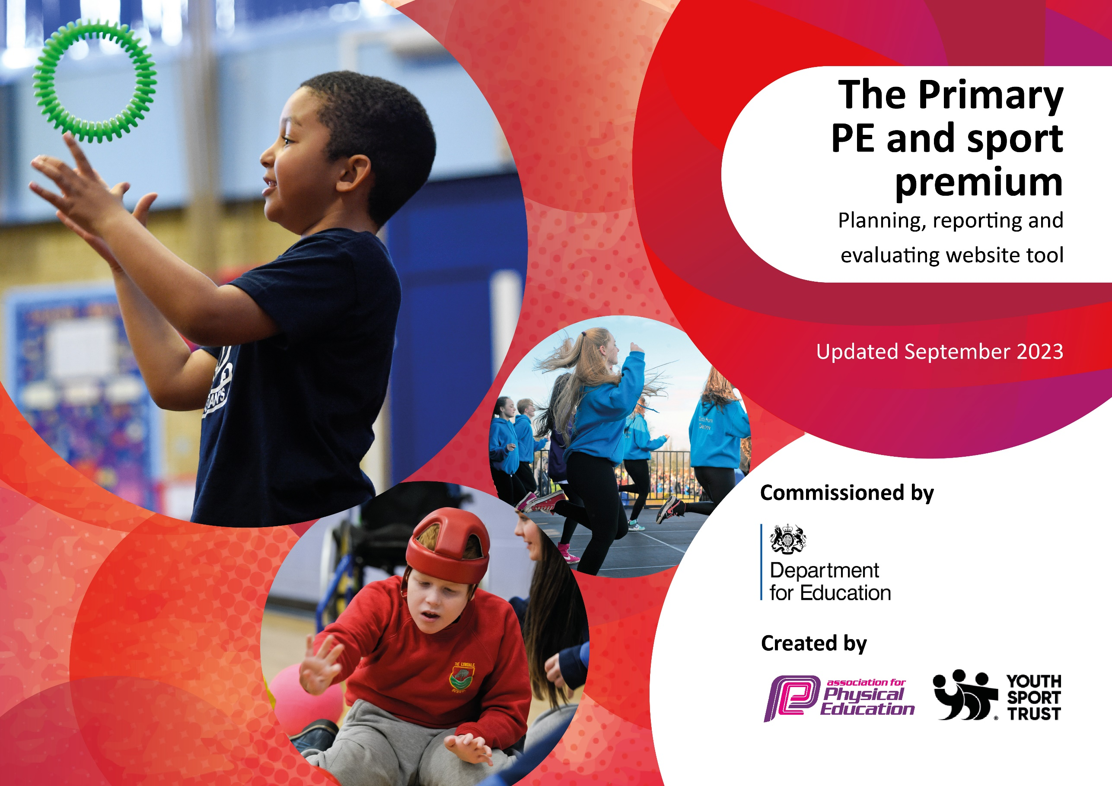

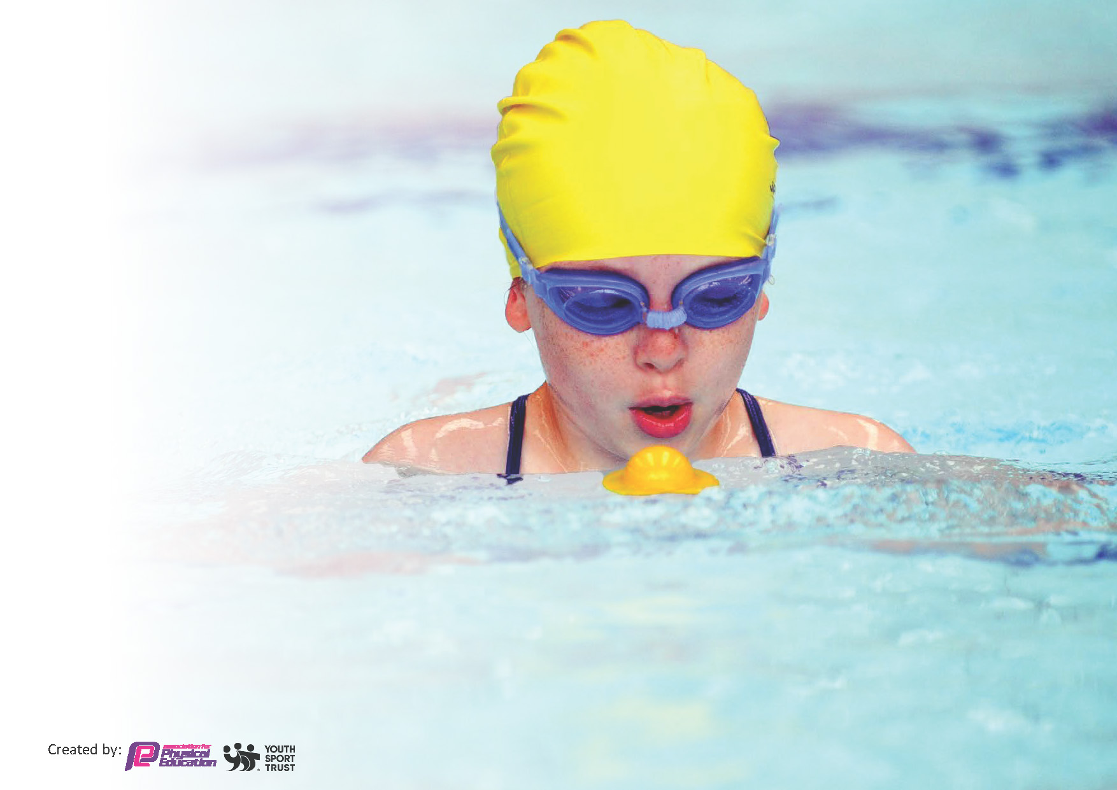
This template can be used for multiple purposes:
by:
- It enables schools to effectively plan their use of the Primary PE and sport premium
- It helps schools to meet the requirements (as set out in guidance) to publish information on their Primary PE and sport premium
- It will be an effective document to support Ofsted inspections enabling schools to evidence progress in Physical Education (PE) and evidence swimming attainment, which forms part of the PE National Curriculum. We would recommend schools consider
the Intent, Implementation and Impact of any spend, as examined within the Education Inspection Framework.

It is important that your grant is used effectively and based on school need.

Schools must use the funding to make additional and sustainable
improvements to the quality of the PE, School Sport and Physical Activity (PESSPA)
they offer. This means that you should use the Primary PE and sport premium to:

- Build capacity and capability within the school to ensure that improvements made now will benefit pupils joining the school in future years
- Develop or add to the PESSPA activities that your school already offers.

The Primary PE and sport premium should not be used to fund capital spend projects; the school’s core budget should fund these. Further detail on capital expenditure can be found in the updated Primary PE and sport premium guidance.

The Primary PE and sport premium guidance, outlines 5 key priorities that funding should be used towards. It is not

necessary that spending has to meet all the key priorities, you should select the priorities that you aim to use any funding towards.

Although completing this template is not a requirement for schools, schools are required to publish details of how they spend this funding. Schools must also outline what the impact this funding has had on pupils’ PE and sport participation and attainment and how any spending will be sustainable in the future. All funding must be spent by 31st July 2024.

The Department for Education has worked closely with the Association for Physical Education (afPE) and the Youth Sport Trust (YST) to develop this template and encourages schools to use it. This template is an effective way of meeting the reporting requirements of the Primary PE and sport premium.
Review of last year’s spend and key achievements (2022/2023)

We recommend you start by reflecting on the impact of current provision and reviewing your previous spend.

Activity/Action | Impact | Comments
- Money has been invested into Moki bands.  - Staff have received CPD for children with SEND in P.E.  - EYFS have received funding to improve fundamental skills.  - Sports Leaders have been trained ready for the new academic year.  - Children have been introduced to new sports to inspire them to be active at home.  - ECT’s have been supported in their first year of teaching P.E.  - P.E. equipment has been improved.  - Sports coaches have been utilised to focus on before/after school provisions and Holiday Camps.  - Additional swimming lessons have been provided for Yr 6 children who haven’t swam 25m.  - Children in KS2 were given the opportunity to take part in competitions. | - Children’s activity levels have been monitored and activity levels during break times when using Moki bands have risen.  - Support staff are more confident in teaching and adapting the teachers lessons to suit the needs of the children.  - Children in EYFS have better equipment that suit the needs of the classroom and improve fundamental skills ready for KS1.  - Sports Leaders will spend time with children outside improving activity levels and playing games with the children.  - All the extra sports days were very well received.  - ECT’s are now confident in teaching P.E. to a good standard.  - The teaching of P.E. will be to a higher standard as the equipment will be better suited to the lessons.  - The children received a wide variety of sports/ activities after-school and the holiday camps ensured that all PP children were given the opportunity to be physically active over the holidays.  - Those children effected were given more opportunity and support to swim 25m.  - Children were able to showcase their talents and skills. | - We will continue to use the Moki bands and monitor the children’s activity levels. Children with lower scores will be monitored by CT and will feedback to me for interventions.  - New members of support staff will be trained to work with the children.  - EYFS lead will meet with the P.E. Lead to talk about extra resources needed.  - Look into booking new sports or repeat sports that were enjoyed by the children.  - The first monitoring cycle will focus on the ECT’s and what further support is required.  - A review of equipment will be carried out by Sports Leaders and myself.  - After-school provisions will continue and Holiday Camps will run as long as they are sustainable. Coaches will be used to implement how we teach the second hour of P.E.  - This will be continued this academic year with both sets of year 6 chidlren.  - Look at finding new ways to have school tournaments without it impacting on the subject leaders time in class.

Key priorities and Planning
This planning template will allow schools to accurately plan their spending. Spent so far £16,949.20

Action – what are you planning to do | Who does this action impact? | Key indicator to meet | Impacts and how sustainability will be achieved? | Cost linked to the action
Introduce coaches to introduce new sports to the children to improve the children’s everyday learning.  Coaches to monitor breaktimes activities at lunch-times on Monday and Friday. | Teaching staff and pupils.  Children’s behavior and activity levels will be impacted | Key indicator 1: The engagement of all pupils in physical activity.  Key indicator 5: Increased participation in competitive sport.  Key indicator 2: The profile of PESSPA being raised across the school as a tool for whole school improvement (Physical Education, School Sport and Physical Activity) | More pupils meeting their weekly and daily physical activity goal, more pupils encouraged to take part in PE and Sport Activities. Teachers will be leading the activities for the rest of the sessions in the week. These sessions will be monitored and eventually can be carried out by teaching staff.  Children’s activity levels at lunch-times will be more meaningful and this will increase some other children’s participation in the Arena at Lunch-times. | £6,415.20 to cover half a day salary for a coach to come in on Monday and Friday each week.  £1764 to cover a professional golf coach to teach in Years Reception,1,2,3,4 and 5  £1,925 to cover the coaches for those break-times.
After-school Clubs will be continued with a wider range of sports for the children to try, along with familiar sports. | Pupils | Key indicator 4: Broader experience of a range of sports and activities offered to all pupils. | Children will be inspired by new sports and be physically active out of school hours. Including taking part in out of school clubs to increase their love of being physically active. | £3,600 for coaches to deliver  £1050 Rugby
To invest in sports equipment to improve the teaching and learning of P.E. | Teachers and Pupils | Key indicator 3: Increased confidence, knowledge and skills of all staff in teaching PE and sport | Staff will have all of the appropriate equipment to teach P.E. according to the sports they have been set out. | £2,195
To invest in staff P.E. kit | Teachers | Key indicator 2: The profile of PESSPA being raised across the school as a tool for whole school improvement (Physical Education, School Sport and Physical Activity) | Staff will become role models to the children by promoting the school uniform and setting the standards for the children. | £315 not spent yet

Key achievements 2023-2024
This template will be completed at the end of the academic year and will showcase the key achievements schools have made with their Primary PE and sport premium spending.

Activity/Action | Impact | Comments

Swimming Data
Meeting National Curriculum requirements for swimming and water safety.
Priority should always be given to ensuring that pupils can perform safe self-rescue even if they do not fully meet the first two requirements of the National Curriculum programme of study

Question | Stats: | Further context  Relative to local challenges
What percentage of your current Year 6 cohort can swim competently, confidently and proficiently over a distance of at least 25 metres? | 80%-6W | Within the 20% of children that couldn’t swim:  2 of the children had never swam before due to COVID restrictions in the last set of lessons and our local pool being closed down for a sustained period of time.  The other 4 were able to swim 25m with a float but lacked confidence due to parents not taking them on a regular basis. All of the children who didn’t swim 25m do not do swimming regularly.  My suggestion would be to send the other Year 6’s that haven’t done it yet along with the other Year 6’s when they go in the Summer Term.
What percentage of your current Year 6 cohort can use a range of strokes effectively [for example, front crawl, backstroke, and breaststroke]? | 80%-6W | I am very pleased with this high percentage of children being able to swim a range of strokes given the restrictions that this year group have faced during the COVID Pandemic. All of the 6 children (as mentioned previously) either had their first experience with swimming this year due to COVID and coming from different schools or had very limited swimming lessons in school due to the restrictions lockdown put us in.  My suggestion would be to send the other Year 6’s that haven’t done it yet along with the other Year 6’s when they go in the Summer Term.

What percentage of your current Year 6 cohort are able to perform safe self-rescue in different water-based situations? | 80%-6W | Use this text box to give further context behind the percentage.
If your schools swimming data is below national expectation, you can choose to use the Primary PE and sport premium to provide additional top-up sessions for those pupils that did not meet National Curriculum  requirements after the completion of core lessons. Have you done this? | Yes/No
Have you provided CPD to improve the knowledge and confidence of staff to be able to teach swimming and water safety? | Yes/No

Signed off by:

Head Teacher: | Mark Paine
Subject Leader or the individual responsible for the Primary PE and sport premium: | Alex Wareing, PE/Sports Premium Lead
Governor: | Thomas Boodell
Date: | September 2023

